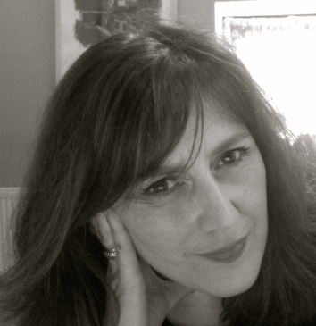
NOELLE NOONAN
Biography
Website www.noellenoonan.ie
http://stateofprint.com/
Noonan works independently and collaboratively using different mediums but primarily print and print installation. Her work traverses the boundaries between traditional printmaking and new technologies in a progressively experimental manner. In recent years she has developed two strong collaborative partnerships Hehir & Noonan and The State of Print. She co-founded the State Of Print an ongoing large scale touring project with international partners in the Scotland, Spain and the UK. These connections initiated a number of projects which advanced the collaborative nature of printmaking and expanded print practice.

Her recent projects include State of Print, large scale touring exhibition (Ireland. Scotland, Spain &England), World Within Worlds, (Hehir & Noonan Collaborative Practice ) Hannah McClure Gallery, Print Festival Scotland, A Room with Your Views, House,( Gillian Wearing, Global Collaboration) Brighton Festival, Impact 9, China 2015 ( H& N) Escape Shift, Cork, The Belltable, Limerick, St Carthage Hall, Lismore Castle Arts, Waterford, Impact 8,Dundee, Scotland. Her work has been exhibited in, Deception and Sacrifice, Southern Graphics International Conference San Francisco, Print Installation Honolulu, Academy Art Centre, Hawaii, USA. and An Eire of the Senses, Irish Contemporary Art at the Ireland World Expo Pavilion, 411 Galleries, Shanghai, China. Noelle has participated in residencies at Tyrone Guthrie Centre, Monaghan 2015 & 2016, Ireland. Selected as Irish candidate to participate in Temporary Residency 3 Honolulu, USA, The Cill Rialaig Project, Co Kerry, Magypolany, Hungary, The Royal University College of Fine Arts Stockholm, Sweden and the Essendine Centre, London.
.

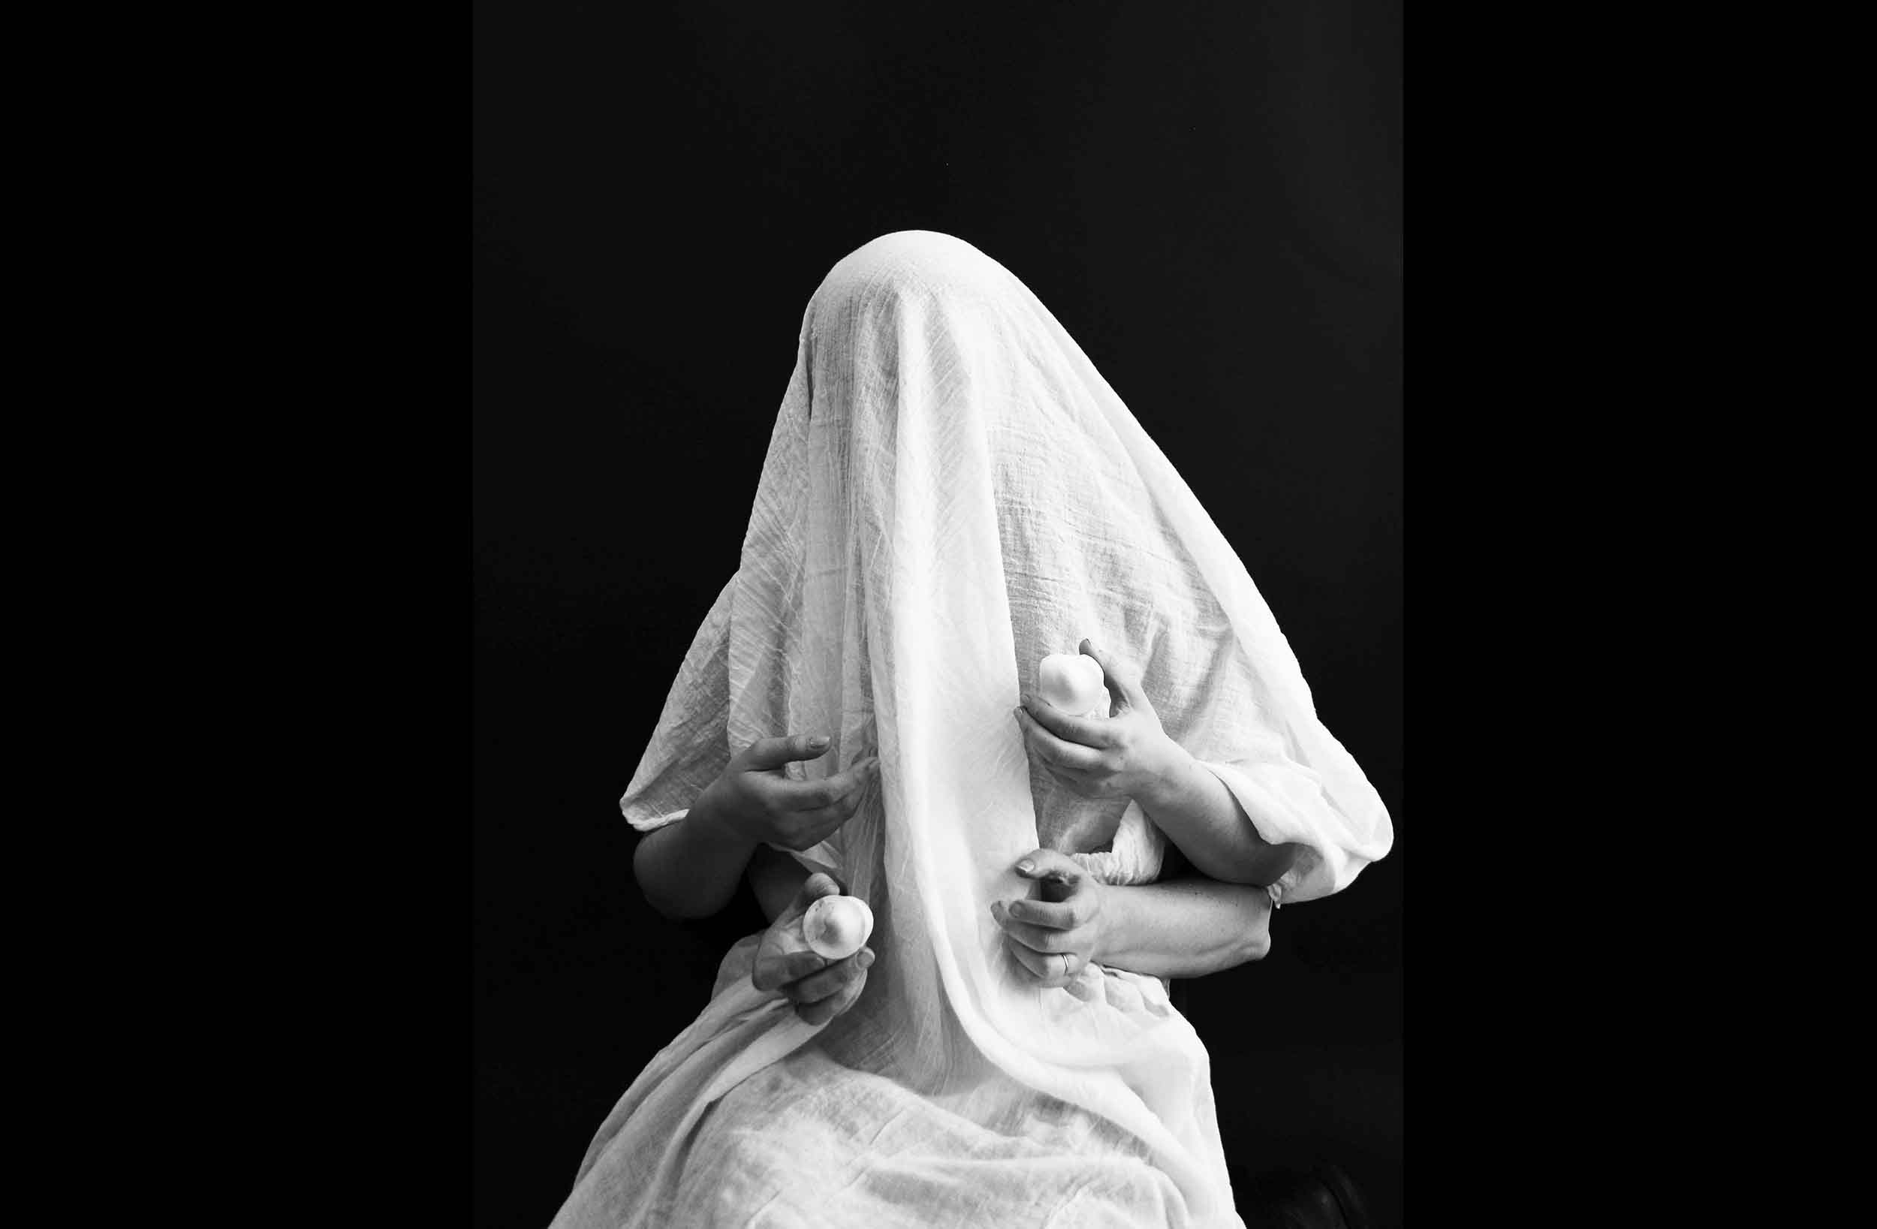

BRIDES Hehir & Noonan Collaboration

PROFESSIONAL EXPERIENCE
1998- to date Part time Lecturer, Print and Contemporary Practice, LSAD, LIT.
1993-1996, Coordinator, Munster Literature Centre, Cork

EDUCATION
Master Degree Fine Art Printmaking, Brighton University England 1990-1992
NCEA Fine Art Painting, Crawford College of Art & Design Cork 1983-1987

AWARDS
2018 Culture Ireland GB 18 Award Fund
2015 Culture Ireland Award
2015 Cork Twinning Grant Award
2013 Art Council Travel and Training Award
1998 Arts Council of Ireland – Art Flight
1998 Arts Council of Ireland – Travel Award 1998 Arts Council of Sweden – Travel Bursary

AWARDED RESIDENCIES
2019 Artist in Residence, Tyrone Guthrie Centre, Co Monaghan
2018 Artist in Residence, Tyrone Guthrie Centre, Co Monaghan
2015 Artist in Residence, Tyrone Guthrie Centre, Co Monaghan
2012 Artist in Residence, Temporary Residency 3 Honolulu, Hawaii
2011 Artist in Residence, Cill Rialaigh Project, Co. Kerry
1999 Artist in Residence, Cill Rialaigh Project, Co. Kerry
1998 Kaleidoscope Residency, Magypolany, Hungary
1998 Kaleidoscope Residency, Royal University College of Fine Arts Stockholm
1993 Artist in Residence, The Essendine Centre, London

MEMBERSHIP
VAI (Visual Artists Ireland) Full membership
1994 to Present Full Member, Cork Printmakers and served on the board for eight years.
1995 to 2007 Studio Member, Backwater Artists Group. Associate member of Limerick Printmakers.

CURATORIAL
2016- to date Co-founder of the State of Print, a multidimensional project which draws on variant areas of research in the field of printmaking.
#PRINTED 5 International Artist Book and Print Event, Eina Espai Barra, Barcelona, April online exhibition, 2020.
#PRINTED 5 International Artist Book and Print Event, Eina Espai Barra, Barcelona, March 2019
ALL INKED UP International Artist Book and Print Event, Kent Canterbury 2017
2017-2018 Volumes (LSAD & CCAD) is a zine collaboration by Noelle Noonan and Catherine Hehir selected for Impact 10, Santander toured to The Grande Parade Gallery, Cork, and the Church Gallery, Limerick.
2015 -2016 Tweetbox (LSAD & CCAD) is a collaborative initiative conceived and co-ordinated by Noelle Noonan and Catherine Hehir selected for Impact 9 China, toured to St Carthage Hall Lismore, Belltable Limerick, Atrium Hall, Cork, Print Festival Scotland.
2005 Guest Curator of graduate show at Colaiste Stiofain Naofa, Cork.

COLLECTIONS
Dean hotel Group, Dáil Eireann, President Michael D Higgins, RTE Cork, RTE Dublin, Bank of Ireland, AIB, UCC, Crawford Municipal Gallery Permanent Collection, OPW, President Mary McAleese, Ormond Quay Hotel, Athlone Regional Technical College, ALDI Corporate Offices, Cork.

RECENT EXHIBITIONS
STATE OF PRINT SOP
A project initiated and developed by Noelle Noonan, Dr Paul Harrison SCT, Scott Hudson, SCT and Catherine Hehir IRl.
2021 State of Print, Impact Hong Kong, April 2021, Online Exhibition.
2020 State of Print, Limerick City Gallery, November 2019-March 2020.
2019 State of Print, Culture night, Crawford College of Art and Design - Cork - September 2019
2019 State of Print 46 Grand Parade Gallery, The Atrium, Cork City Council & Cork Printmakers
(Mid-Summer Festival).
2019 State of Print, Dundee Contemporary Arts 20 Years, Scotland.
2018, State of Print, Harrington's Social Space, Artlab, UCLA, Preston England.
2018 State of Print, Nunnsyard Gallery, 23-25 St Augustine St, Norwich, England.
2018 State of Print EINA, Ambaixada de Barcelona, Spain.
2018 State of Print, Impact 10, Santander, Spain.
2018 State of Print, The Worm, Peacock Visual Arts, Aberdeen.
2018 State of Print, Generator & Centrespace, Dundee, Scotland.

LINKS TO STATE OF PRINT REVIEWS/ARTICLES
http://artlabcontemporaryprint.org.uk/2019/01/08/state-of-print/
https://minorliteratures.com/2018/07/20/state-of-print-christiana-spens/
https://twitter.com/hashtag/stateofprint
https://www.instagram.com/explore/tags/stateofprint/top/?hl=en

LINKS TO SOP VIDEOS
SOP Intro and archivehttps://youtu.be/BvgMESfWES4
SOP Archive 2 https://youtu.be/6yLFyjmyRko
SOP Eurovision https://youtu.be/JHjzHCb_ae0

SELECTED EXHIBITIONS
2021 Brides, Collaboration (Hehir & Noonan), Cork Printmaker 30th, Lavitt Gallery, Cork.
2021 Brides, Collaboration (Hehir & Noonan), Impact Hong Kong, Online Exhibition
2020 London Art Fair
2020 State of Print, Limerick City Gallery.
2019 VUE RHA, Dublin
2017 Ballot, East Gallery, Norwich, UK. October 2017.
2017 Ballot, CIT Gallery, Cork, Ireland. October 2017.
2016 Dazzle, Wandesford Quay, Cork.
2016 Worlds within Worlds, collaboration (Hehir & Noonan) Hannah McClure Gallery, Scotland.
2016 A Room with your views, Gillian Wearing, Global Collaboration.
2016 Cork Printmakers at the Lavitt, Cork.
2016 Present, The Centre for Contemporary Printmaking, Connecticut, U.S.A
2016 Escape Shift, Print Collaboration (Hehir& Noonan) touring Belltable Limerick & Atrium, Cork.
2015 Escape Shift, Print collaboration (Hehir& Noonan) Impact 9, China.
2015 Escape Shift, St Carthage Hall, Lismore Arts Centre, Waterford
2015 All Things Considered, Wandesford Quay Gallery, Cork
2015 Plane Invasion, Limerick School of Art and Design, Limerick.
2015 Impressions, Galway Arts Centre, Galway.
2014 Deception & Sacrifice, CIT Wandesford Quay Gallery.
2014 Steller, CIT Gallery, Wandesford Quay, Cork.
2014 An Irish Connection, Tussock Gallery, Victoria, Australia.
2014 Deception and Sacrifice, Southern Graphic International Conference, San Francisco
2014 Nova, CIT Gallery Wandesford Quay, Cork City
2013 Impact 8, Printmaking Exhibition & Conference, Dundee, Scotland.

SELECTED PAPERS & PUBLICATIONS
2021 IMPACT 11 Hong Kong, illustrated talk , Paper and Exhibition.
Online programme catalogue, April 2021.
2018 Article in Printmaking today Autumn issue
2018 DURTY WORDS PUBLICATION, 2018,
A space for dialogue, solidarity, resistance and Creation
2018 Review Printmaking today Winter issue 2018
2018 Review Lancashire Post Newspaper 5 Dec 2018
2018 IMPACT 10 Encuentro Santander Northern Spain.
Publication, open portfolio and Performance. 2018 0nline catalogue.
2017 All INKED UP Book Art Symposia,
University of Kent, Public talk & Conference exhibition
2015 Printmaking in the Post-Print Age. Conference Paper – Impact 9,Published by China Academy of Art Press 2015, ISBN: 978 7 5503 0957 9
2015 Hehir & Noonan Collaborative Practice Catalogue.
2013 Borders & Crossings: the artist as explorer Impact 8 Conference Exhibition
and illustrated talk .Panel discussion. Published by Duncan of Jordanstone College of Art & Design, ISBN: 1-899837-70-1.
2012 Print Installation Temporary Residency 3 Catalogue, Honolulu, Hawaii.
2012 Aether Catalogue, Town hall, Macroom, Cork.
2011 National Interest, ArtTrail Publication.
2010 21 Cork Printmakers Catalogue.
2010 Backwater Twenty 2010 Catalogue.
2010 Eire of the Senses Catalogue, Irish Contemporary Art at the World Expo Pavilion, Shanghai, China.
2009 Wrexham Print International Catalogue, Oriel Wrexham, Wales.
2009 Today I joined the gang in the woods, Triskel Publication.
2005 Cló In China, Contemporary Irish Printmaking Catalogue.
2009 Drawing Eire, 411 Galleries Shanghai, China.
2008 Is Mise Eire Catalogue, 411 Galleries, China
2004 The Wandesford Quay Project Catalogue.
2004 C2, Catalogue, Crawford Municipal Gallery, Cork.
1994 Despatches, Crawford Municipal Art Gallery, Cork.

