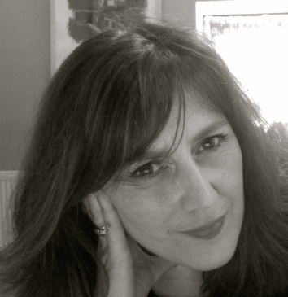
Noelle Noonan

Biography
Website www.noellenoonan.ie
https://www.facebook.com/Hehir-Noonan
Noelle Noonan’s work traverses the boundaries between traditional printmaking and new technologies in a progressively experimental manner. Recently she has been collaborating with fellow artist Catherine Hehir using a number of different media but primarily print. The process of multiplicity in printmaking is strongly evident in the work presenting opportunities to develop expanded print forms.

Her projects include World Within Worlds, (Hehir & Noonan Collaborative Practice ) Hannah McClure Gallery, Print Festival Scotland, A Room with Your Views, House,( Gillian Wearing, Global Collaboration) Brighton Festival, Impact 9, China 2015 ( H& N) Escape Shift, Cork, The Belltable, Limerick, St Carthage Hall, Lismore Castle Arts, Waterford, Impact 8,Dundee, Scotland. Her work has been exhibited in, Deception and Sacrifice, Southern Graphics International Conference San Francisco, Print Installation Honolulu, Academy Art Centre, Hawaii, USA. and An Eire of the Senses, Irish Contemporary Art at the Ireland World Expo Pavillion, 411 Galleries, Shanghai, China. Noelle has participated in residencies at Tyrone Guthrie Centre, Monaghan 2015 & 2016, Ireland. Selected as Irish candidate to participate in Temporary Residency 3 Honolulu, USA, The Cill Rialaig Project, Co Kerry, Magypolany, Hungary, The Royal University College of Fine Arts Stockholm, Sweden and the Essendine Centre, London.
Noelle is currently employed as lecturer in Print and Contemporary Practice at Limerick School of Art and Design.

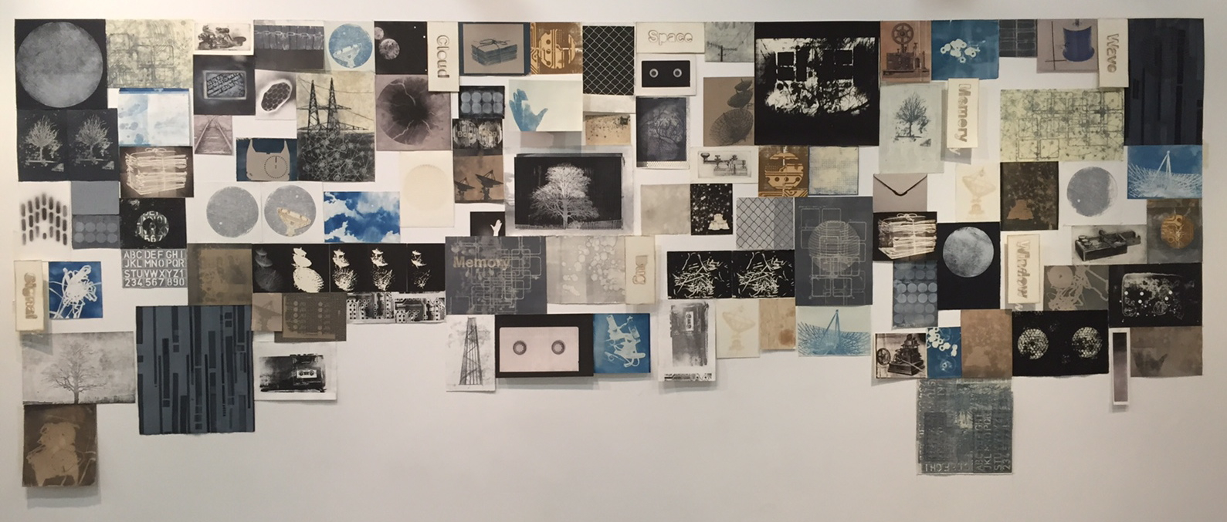
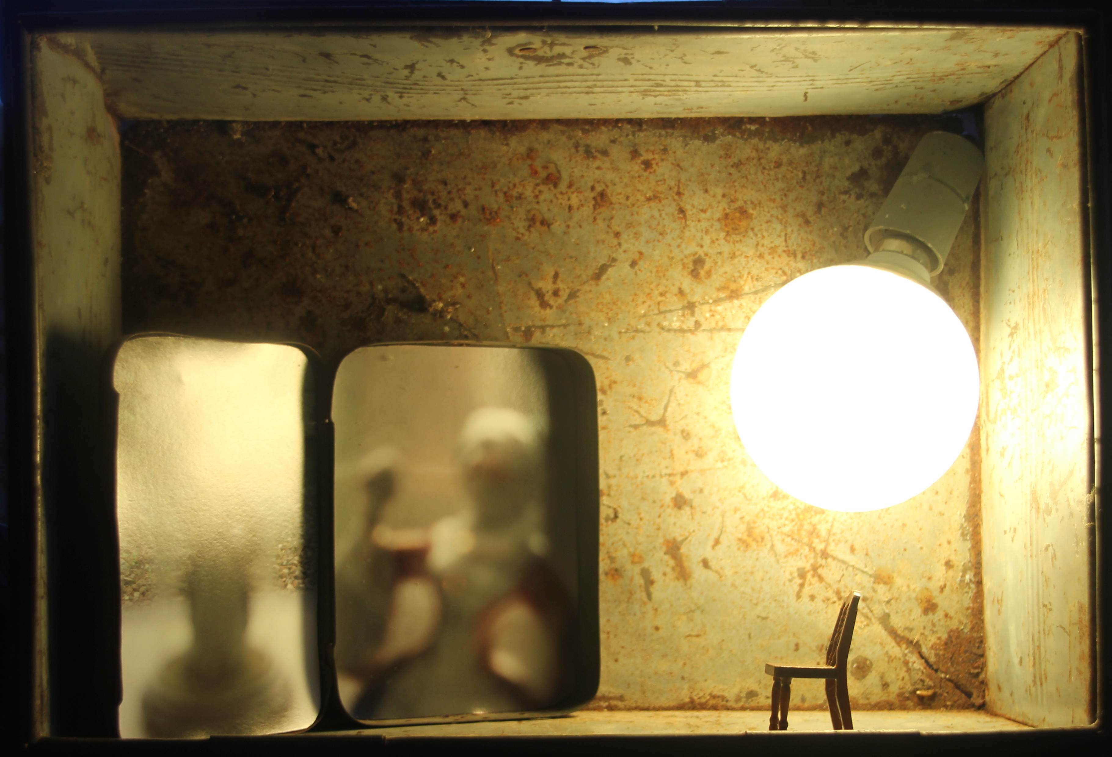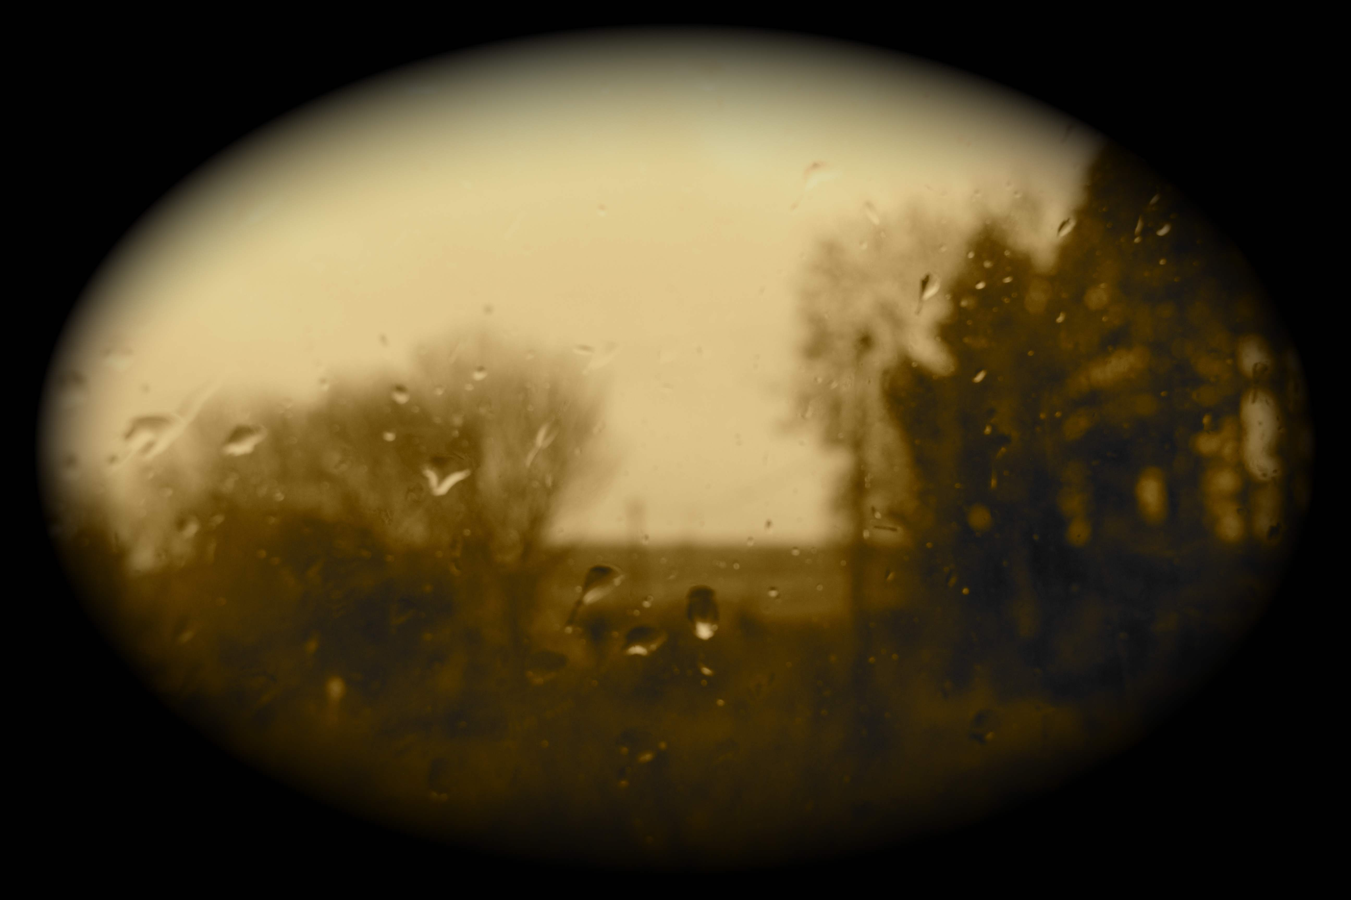
Crypto digital print and found objects, Winter archival pigment print and Escape Shift multi-panel prints (Hehir & Noonan)
PROFESSIONAL EXPERIENCE
1998- to date Lecturer, Print and Contemporary Practice, LSAD, LIT
1993-1996, Coordinator, Munster Literature Centre, Cork

EDUCATION
Master Degree Fine Art Printmaking, Brighton University England 1990-1992
NCEA Diploma Fine Art Painting, Crawford College of Art & Design Cork 1983-1987
Visual Education Certificate, Crawford College of Art and Design 1982-1983

AWARDS
2015 Culture Ireland Award
2015 Cork Twinning Grant Award
2013 Art Council Travel And Training Award
1998 Arts Council of Ireland – Art Flight
1998 Arts Council of Ireland – Travel Award
1998 Arts Council of Sweden – Travel Bursary
RESIDENCIES
2015 Artist in Residence, Tyrone Guthrie Centre, Monaghan
2012 Artist in Residence, Temporary Residency 3 Honolulu, Hawaii
2011 Artist in Residence, Cill Rialaigh Project, Co. Kerry
1999 Artist in Residence, Cill Rialaigh Project, Co. Kerry
1998 Kaleidoscope Residency, Magypolany, Hungary
1998 Kaleidoscope Residency, Royal University College of Fine Arts Stockholm
1993 Artist in Residence, The Essendine Centre, London

MEMBERSHIP
1994 to Present Full Member, Cork Printmakers and served on the board for eight years.
1995 to 2007 Studio Member, Backwater Artists Group.
Associate member of Limerick Printmakers.

OTHER
2015 -2016 Tweetbox ( LSAD & CCAD) is a collaborative initiative concieved and co-ordinated by Noelle Noonan and Catherine Hehir selected for Impact 9 China, toured to St Carthage Hall Lismore, Belltable Limerick, Atrium Hall, Cork, Print Festival Scotland.
2005 Guest Curator of graduate show at Colaiste Stiofain Naofa, Cork.

COLLECTIONS
Dáil Eireann, RTE Cork, RTE Dublin, Bank of Ireland, AIB, UCC, Crawford Municipal Gallery, OPW, President Mary McAleese, ALDI Corporate Offices, Cork.

SELECTED EXHIBITIONS
2017 Ballot, East Gallery, Norwich, UK. October 2017.
2017 Ballot, CIT Gallery, Cork, Ireland. October 2017.
2016 Dazzle,Wandesford Quay, Cork
2016 Worlds within Worlds, Hannah McClure Gallery, Scotland
2016 A Room with your views, Gillian Wearing, Global Collaboration
2016 Cork Printmakers at the Lavitt, Cork
2016 Present, The Centre for Contemporary Printmaking, Connecticut, U.S.A
2016 Escape Shift, Print Collaboration ( Hehir& Noonan) touring Belltable Limerick, Atrium, Cork
2015 Escape Shift, Print collaboration ( Hehir& Noonan) Impact 9, China
2015 Escape Shift , St Carthage Hall , Lismore Arts Centre, Waterford
2015 All Things Considered , Wandesford Quay Gallery, Cork
2015 Plane Invasion, Limerick School of Art and Design
2015 Impressions, Galway Arts Centre, Galway
2014 Deception & Sacrifice, CIT Wandesford Quay Gallery, May 2014
2014 Steller, CIT Gallery, Wandesford Quay, Cork
2014 An Irish Connection, Tussock Gallery, Victoria, Australia
2014 Deception and Sacrifice, Southern Graphic International Conference, San Francisco
2014 Nova, CIT Gallery Wandesford Quay, Cork City
2013 Impact 8, Printmaking Exhibition & Conference, Dundee, Scotland
2013 PrintED, LSAD Gallery, Limerick
2012 21, CIT Wandesford Quay and Atrium Hall, City Hall, Cork
2012 Perimeter, Limerick Printmakers Gallery, Limerick
2012 Aether, Macroom Town Hall, County Cork
2012 Print Installation, Academy Art Centre Hawaii.
2012 Impressions 12, Galway Arts Centre, Galway '12
2011 Limerick/Quimper Cross Cultural Art Exhibition, Belltable Art Centre and Prieure de Locmaria, Quimper, France.
2011 24hours, Cork Printmakers
2011 Alphabet Series, Irish Art Centre, New York.
2011 Pop up Print, 24 Print Marathon, Limerick Printmakers Gallery
2010 20 : 20 Studio Exchange Project, Hot Bed Press, Manchester
2010 Excavate, Cork Public Museum, Fitzgeralds Park, Cork.
2010 An Eire of the Senses, Irish Contemporary Art at the Ireland World Expo Pavillion, 411. Galleries, Shanghai, China
2010 Backwater Twenty-10,Crawford Art Gallery, Cork
2009 Today I joined the gang in the woods, Triskel Art Centre, Cork
2009 Print Zero, Seattle, USA
2009 Drawing Eire, 411 Galleries Shanghai, China
2009 Wrexham International Print Exhibition, Wrexham, Wales. (Touring Show)
2008 Cork Printmakers Group show, Donkey Mill Art Centre, Hawaii
PUBLICATIONS
2015 Impact 9, China Academy of Art Press
2015 Hehir & Noonan Collaborative Practice
2013 Impact 8,Duncan of Jordanstone College of Art and Design Publication, Scotland
2012 Print Installation Temporary Residency 3 Catalogue, Honolulu, Hawaii
2012 Aether Catalogue, Town hall, Macroom, Cork
2011 National Interest, ArtTrail Publication
2010 21 Cork Printmakers Catalogue
2010 Backwater Twenty 2010 Catalogue
2010 Eire of the Senses Catalogue, Irish Contemporary Art at the World Expo Pavillion, Shanghai, China
2009 Wrexham Print International Catalogue,Oriel Wrexham, Wales
2009 Today I joined the gang in the woods, Triskel Publication
2005 Cló In China, Contemporary Irish Printmaking Catalogue
2009 Drawing Eire, 411 Galleries Shanghai, China.
2008 Is Mise Eire Catalogue, 411 Galleries, China
2004 The Wandesford Quay Project Catalogue
2004 C2, Catalogue, Crawford Municipal Gallery, Cork,
1994 Despatches, Crawford Municipal Art Gallery

